**UAV Captured Image Segmentation Using U-Net Architecture**

A Paper

Submitted in Partial Fulfilment of the Requirements

for the Award of the Degree of

**Bachelor of Technology**

in

Computer Science & Engineering

Submitted by

**Alokkumar Anshuman Bharti (2006018)**

**Amar Ram (2006037)**

**Ankit Kumar (2006053)**

Under the supervision of

**Dr. Rajib Ghosh**

(Assistant professor Grade 1)



Department of Computer Science & Engineering

National Institute of Technology Patna

Jan-Jun 2023



**Certificate**

The undersigned certifies that **Alokkumar Anshuman Bharti** (Roll. No. **2006018)**, **Amar Ram** (Roll. No. **2006037**) and **Ankit Kumar** (Roll. No. **2006053**) are registered student for the bachelor’s program in **Department of Computer Science & Engineering** with specialization in Computer Science & Engineering under my supervision.

I hereby recommend that the paper entitled, **“UAV Image segmentation using U-Net Architecture”** be accepted as the partial fulfilment of the requirements for evaluation and award of the B.Tech. Degree.

**_________________________________________________________**

**Dr. Rajib Ghosh**

Assistant Professor-Grade-1

Department of Computer Science & Engineering

National Institute of Technology Patna

May 2023



**Declaration & Copyright**

I, Alokkumar Anshuman Bharti, Amar Ram, and Ankit Kumar, declare that this paper entitled, “**UAV Image segmentation using U-Net Architecture**” is my own original work and it has not been presented and will not be presented to any other University/ Institute for a similar or any other degree award.

Alokkumar Anshuman Bharti (2006018): _______________________________

Amar Ram (2006037): ______________________________________________

Ankit Kumar (2006053): _____________________________________________

**________________________________________________________________**

This paper is a copyright material protected under the Berne Convention, the copy right of 1999 and other International and National enactments, in that behalf, or intellectual property. It may not be reproduced by any means, in full or in part, except for short extracts in fair dealing, for research or private study, critical scholarly review or discourser with an acknowledgment, without written permission of the Department on both the author and NIT Patna.

**Acknowledgements**

I would like to take the opportunity to thank those people who guided me and supported me during this period of my study. Without their valuable contributions, this paper work would not have been possible.

I am highly thankful for my B. Tech. supervisor, Dr. Rajib Ghosh (CSE Dept.), for his guidance, advice and support throughout the entire paper work. I have been really lucky and given a chance by the almighty, to be working with him. This paper could not have been completed without his supervision and support. As my supervisor, he provided me with the encouragement and freedom to pursue my own ideas. He was always patient, even when i wasn’t, and helpful whenever his guidance was needed.

This work would not have been possible without the cooperation and support of my colleagues and friends. I am also thankful to all staff members of the Computer Science & Engineering Department for their useful help. I would also like to thank the continuous support and encouragement provided by my parents, who kept me motivated and cheered in the most difficult of times.

Alokkumar Anshuman Bharti (2006018)

B. Tech (CSE) – 6th Semester

Amar Ram (2006037)

B. Tech (CSE) – 6th Semester

Ankit Kumar (2006053)

B. Tech (CSE) – 6th Semester

***Abstract***

*The aerial images of the earth’s surface captured by satellites and unmanned aerial vehicles (UAVs)have great potential to support applications in various domains, especially robotics-based solutions for smart urban planning, terrain classification, vegetation detection, agriculture planning, and environmental surveillance.*

*The proposed end-to-end convolutional neural network (CNN) architecture consists of contracting and symmetric expanding paths that precisely extract the global features to segment the different class from the aerial image. The proposed architecture is evaluated on the NITRDrone Dataset.*

**Contents**

**Certificate** 1

**Declaration & Copyright** 2

**Acknowledgements** 3

**Abstract** 4

**Chapter**

1. Introduction 7

2. Literature Survey 10

3. Problem Statement 11

4. Proposed Methodology 13

5. Implementation and Result Analysis 17

6. Conclusion and Future Scope 21

References 23

**Chapter 1**

**Introduction**

Semantic segmentation of images, i.e., assigning labels to each pixel, has been widely studied in the field of computer vision. Time is extremely critical in post-disaster situations for prompt relief efforts. Timely and accurate road maps are also extremely important for navigation in post-disaster scenarios. Pre-existing maps can be rendered inaccurate due to possible route blockages, water-logging, landslides, and structural damages.

The satellite based captured images have been used to address many societal issues at a higher level through different RS (Remote Sensing) applications. However, certain gaps in satellite-based RS applications make it difficult to go through the tropical regions, which are mostly covered by clouds. UAVs can help satellites overcome their limitations and accomplish particular tasks through real-time assessment and monitoring actions in different scenarios. Deep learning (DL) based techniques such as convolutional neural networks (CNN) are becoming increasingly pervasive as a means of automating the knowledge discovery process in many fields including remote sensing.

**1.1 Motivation**

Motivation of using CNN: With ANN, concrete data points must be provided. For example, in a model where we are trying to distinguish between dogs and cats, the width of the noses and length of the ears must be explicitly provided as data points. When using CNN, these spatial features are extracted from image input. This makes CNN ideal when thousands of features need to be extracted. Instead of having to measure each individual feature, CNN gathers these features on its own. Using ANN, image classification problems become difficult because 2-dimensional images need to be converted to 1-dimensional vectors. This increases the number of trainable parameters exponentially. Increasing trainable parameters takes storage and processing capability. In other words, it would be expensive. Compared to its predecessors, the main advantage of CNN is that it automatically detects the important features without any human supervision. This is why CNN would be an ideal solution to computer vision and image segmentation problems.

**1.2 Challenges**

Image segmentation is the process of dividing an image into different regions or segments based on their visual properties such as color, texture, and shape. It is a crucial step in many computer vision applications such as object recognition, autonomous driving, and medical image analysis. However, there are several challenges in image segmentation in machine learning:

**1.2.1 Complex Object Shapes:**

Objects in an image can have complex shapes, making it difficult to identify and segment them accurately. This is particularly challenging when objects overlap or occlude each other.

**1.2.2: Class Imbalance:**

In many image segmentation tasks, some classes of objects may be much rarer than others. This can lead to a class imbalance problem where the model may not perform well on the rare classes.

**1.2.3: Real-Time Performance**:

In some applications, such as autonomous driving, image segmentation needs to be performed in real-time. This can be challenging as segmentation models can be computationally intensive, and the inference time needs to be fast enough to keep up with the real-time requirements.

**1.2.4: Generalization:**

The segmentation model needs to be able to generalize to new and unseen images that may have different lighting conditions, backgrounds, and object configurations. Overfitting can be a common problem, particularly when the training data is limited.

**1.2.5: Interpretability**:

Understanding how the segmentation model arrives at its predictions is crucial in many applications such as medical image analysis. However, many deep learning-based segmentation models are black boxes, making it challenging to interpret their decisions

**1.3 Proposed Solution**

There are many deep learning CNN based architectures which can be used for image segmentation. In this, we have used U-Net architecture for aerial image segmentation. **U-Net** consists of a contracting path and an expansive path. The contracting path follows the typical architecture of a convolutional network.

**1.4 Objective**

The goal of the project is to develop a system that can segment a UAV captured image and classify its different regions in the four different classes that are road, vegetation, background and occluded road.

**Chapter 2**

**Literature Survey**

Image segmentation on the real-world data that will identify the four classes listed below. Road, Vegetation, Background, Occluded Road.

|  |  |  |  |  |  |
| --- | --- | --- | --- | --- | --- |
| Title | Task | Image type | Features | Classifier | Results |
| [1] | image segmentation | aerial images | Convolutional | TreeUNet | 89.3(mean F1) |
| [2] | image segmentation | aerial images | Convolutional | LinkNet (ResNet34) | 94.76(F_score) |
| [3] | image segmentation | Brain images | Convolutional | ResNets | 86(Accuracy) |
| [4] | image segmentation | aerial images | Convolutional | fuzzy local information C-means (FLICM) | 82.7(Accuracy) |
| [5] | image segmentation | aerial images | Convolutional | J-measure-based segmentation method | 93 |
| [6] | image segmentation | aerial images | Convolutional | Multiscale Optimization Procedure | 20-40% improvement |
| [7] | image segmentation | aerial images | Convolutional | U-net | 82 |
| [8] | image segmentation | aerial images | Convolutional | FCN | 87.9 |
| [9] | image segmentation | aerial images | Convolutional | (Evo.NAS)  SLGENet-3 | 92.1 |
| [10] | image segmentation | aerial images | Convolutional | MultiScale CNN | 99.4 |

Overall, the literature on image segmentation is vast, and there are many different approaches and techniques for addressing the various challenges. Deep learning-based methods have shown significant improvements in image segmentation performance, and there is ongoing research to develop more efficient and accurate models.

**Chapter 3**

**Problem Statement**

Using the concatenation of CNN features, this study seeks to segment the UAV captured image into four classes:

* Background
* Road
* Occluded Road
* Vegetation.

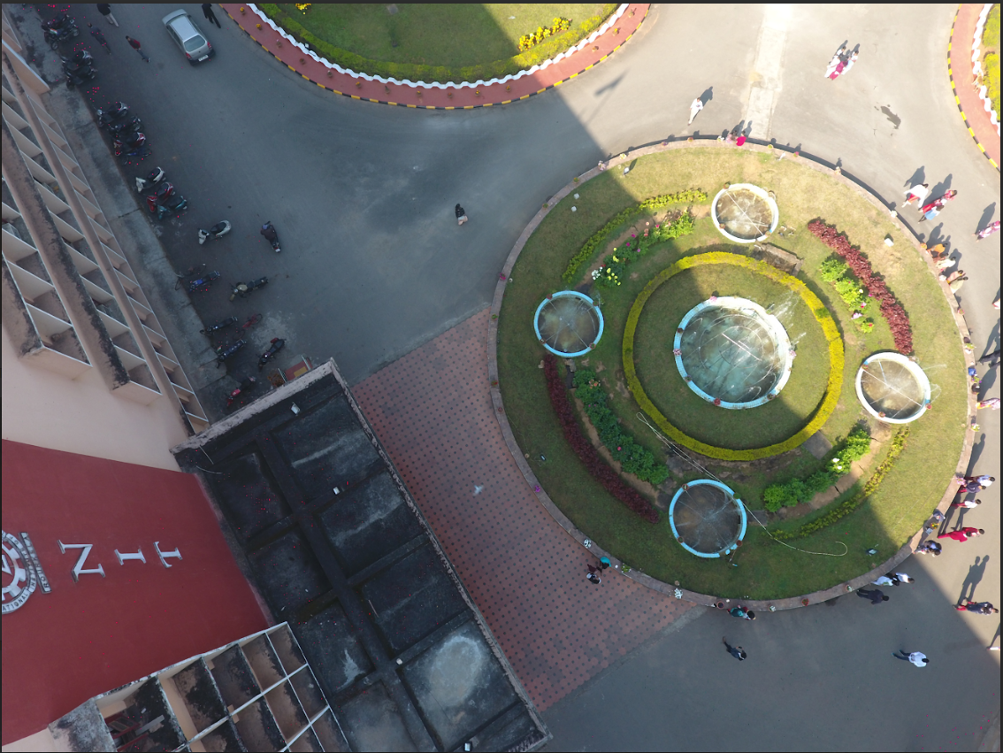

Figure 2.1: Sample image data from NITRDrone dataset

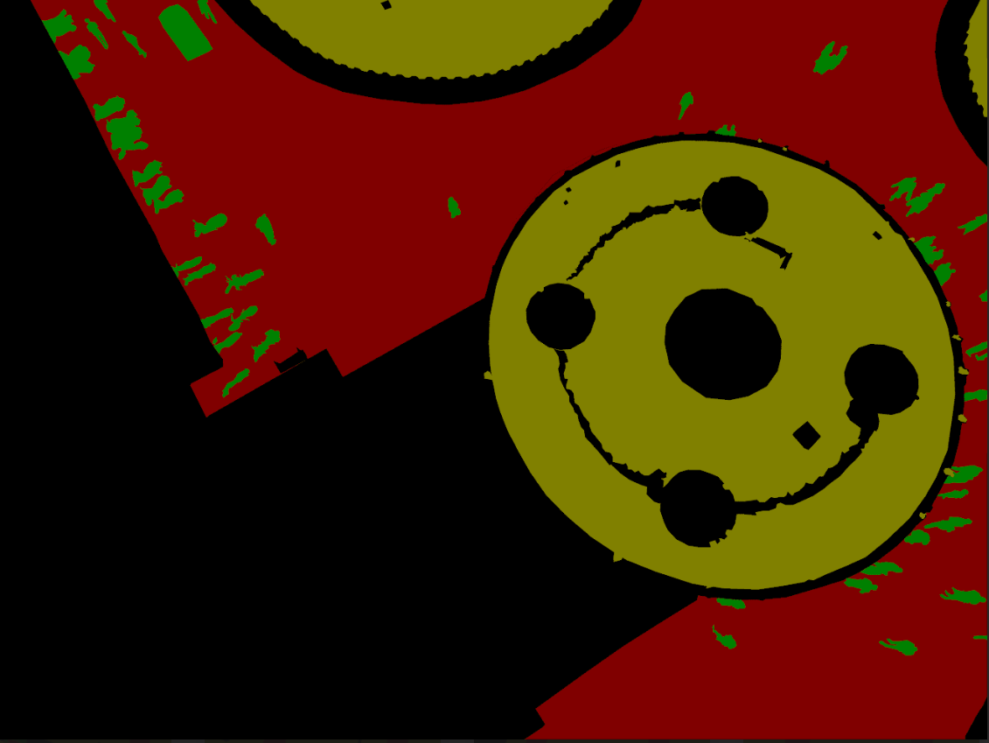

Figure 2.2: Sample mask data from NITRDrone dataset

**Chapter 4**

**Proposed Methodology**

In this section, the paper explains our proposed solution for UAV captured image segmentation using convolutional features. There are many deep learning CNN based architectures which can be used for image segmentation. In this, we have used U-Net architecture for aerial image segmentation. U-Net consists of a contracting path and an expansive path. The contracting path follows the typical architecture of a convolutional network. It consists of the repeated application of two 3x3 convolutions (unpadded convolutions), each followed by a rectified linear unit (ReLU) and a 2x2 max pooling operation with stride 2 for down sampling. At each down sampling step we double the number of feature channels. Every step in the expansive path consists of an up sampling of the feature map followed by a 2x2 convolution (“up-convolution”) that halves the number of feature channels, a concatenation with the correspondingly cropped feature map from the contracting path, and two 3x3 convolutions, each followed by a ReLU. The cropping is necessary due to the loss of border pixels in every convolution. At the final layer a 1x1 convolution is used to map each 64-component feature vector to the desired number of classes.

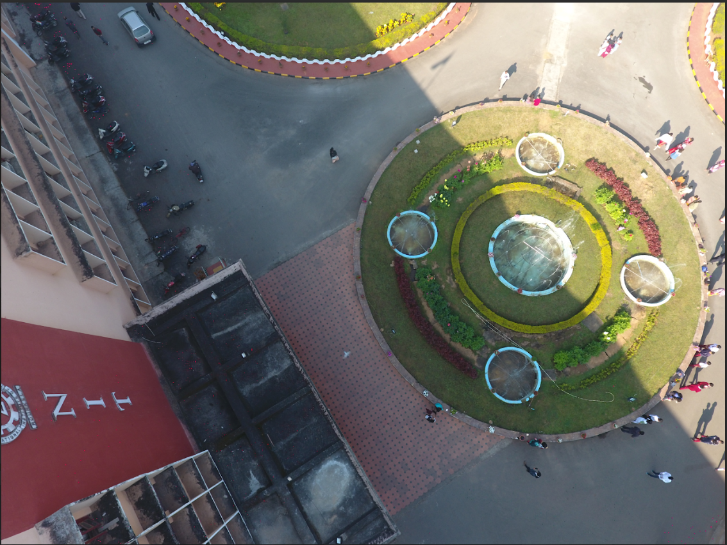 

Image

Figure 4.1: CNN based U-Net Architecture

**4.1 The Intuition behind U-Net**

The main idea behind CNN is to learn the feature mapping of an image and exploit it to make more nuanced feature mapping. This works well in classification problems as the image is converted into a vector which used further for classification. But in image segmentation, we not only need to convert feature map into a vector but also reconstruct an image from this vector. This is a mammoth task because it’s a lot tougher to convert a vector into an image than vice versa. The whole idea of UNet is revolved around this problem.

While converting an image into a vector, we already learned the feature mapping of the image so why not use the same mapping to convert it again to image. This is the recipe behind UNet. Use the same feature maps that are used for contraction to expand a vector to a segmented image. This would preserve the structural integrity of the image which would reduce distortion enormously.

**4.2 U-Net Architecture**

It consists of following 4 things:

**4.2.1 Encoder Network**

The encoder network acts as the feature extractor and learns an abstract representation of the input image through a sequence of the encoder blocks. Each encoder block consists of two 3x3 convolutions, where each convolution is followed by a ReLU (Rectified Linear Unit) activation function. The ReLU activation function introduces non-linearity into the network, which helps in the better generalization of the training data. The output of the ReLU acts as a skip connection for the corresponding decoder block.

Next, follows a 2x2 max-pooling, where the spatial dimensions (height and width) of the feature maps are reduced by half. This reduces the computational cost by decreasing the number of trainable parameters.

**4.2.2 Skip Connections**

These skip connections provide additional information that helps the decoder to generate better semantic features. They also act as a shortcut connection that helps the indirect flow of gradients to the earlier layers without any degradation. In simple terms, we can say that skip connection helps in better flow of gradient while backpropagation, which in turn helps the network to learn better representation.

**4.2.3 Bridge**

The bridge connects the encoder and the decoder network and completes the flow of information. It consists of two 3x3 convolutions, where each convolution is followed by a ReLU activation function.

**4.2.4 Decoder Network**

The decoder network is used to take the abstract representation and generate a semantic segmentation mask. The decoder block starts with a 2x2 transpose convolution. Next, it is concatenated with the corresponding skip connection feature map from the encoder block. These skip connections provide features from earlier layers that are sometimes lost due to the depth of the network. After that, two 3x3 convolutions are used, where each convolution is followed by a ReLU activation function.

The output of the last decoder passes through a 1x1 convolution with sigmoid activation. The sigmoid activation function gives the segmentation mask representing the pixel-wise classification.

**Chapter 5**

**Implementation and Result Analysis**

**5.1 Dataset Description**

The NITRDrone dataset is proposed and built on seeing the rising demand for UAV-based applications for scene understanding that uses semantic segmentation-based techniques. The dataset contains around 101 number of variable resolutions of VHR images captured with the help of DJI Phantom 4 and DJI Mavic drone having ground sampling distance (GSD) of 0.025 sq. cm/pixel. The resolution of an image in the dataset can be any of the following 1280 × 720, 4000 × 3000, 4096 × 2160. A pixel can belong to any of the four different considered classes named “road”, “vegetation”, “occluded road,” and “background”. Some of the sample images and their corresponding ground truths of the dataset are presented in Fig.5.1

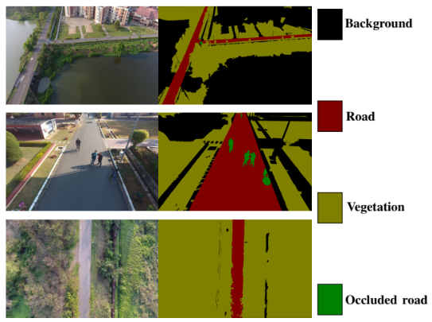

Figure 5.1: NITRDrone dataset containing UAV captured aerial outdoor images

Table 5.1: Number of images in each resolution

|  |  |  |
| --- | --- | --- |
| Resolution (720 X 1280) | Resolution (2160 X 4096) | Resolution (3000 X 4000) |
| 31 | 51 | 19 |

Table 5.2: Number of images in each set

|  |  |  |
| --- | --- | --- |
| Training set | Validation set | Testing set |
| 31 | 51 | 19 |

**5.2 Implementation**

The “U” shaped model comprises convolutional layers and two networks. First is the encoder, which is followed by the decoder. Firstly, the images are cropped to a size of 512 x 512 using patchify library. These images are stored in an array names image_dataset and mask_dataset. The corresponding labels from masks images are obtained which has 4 unique lables:0, 1, 2, and 3. The dataset is splitted into training and validation dataset in the 80:20 ratio and random state as 42. Adaptive moment estimation is considered the optimizer and Cross-Entropy (CE) is used as a loss function. The batch size is initialize to 4. The model is trained for several epochs. The CNN implementation was done using TensorFlow package and keras library. All the code was implemented using Python programming language.

**5.3 Proposed models Hyperparameters**

In machine learning, a hyperparameter is a parameter whose value is used to control the learning process. By contrast, the values of the other parameters are calculated via training. Different model training algorithms require different hyperparameters.

|  |  |
| --- | --- |
| **Hyperparameters** | **Values** |
| Batch Size | 8 |
| Optimizer | Adam |
| Loss function | Cross-Entropy |
| No. of Convolution layers | 15 |
| Filter size | 3*3 in both convolution layers |
| Activation function in output layer | SoftMax |
| No. of trainable parameters | 7607138 |
| Activation function in hidden layer | ReLu |

**5.4 Result analysis**

After training the model for several epochs and testing it on test dataset, the following result is obtained.

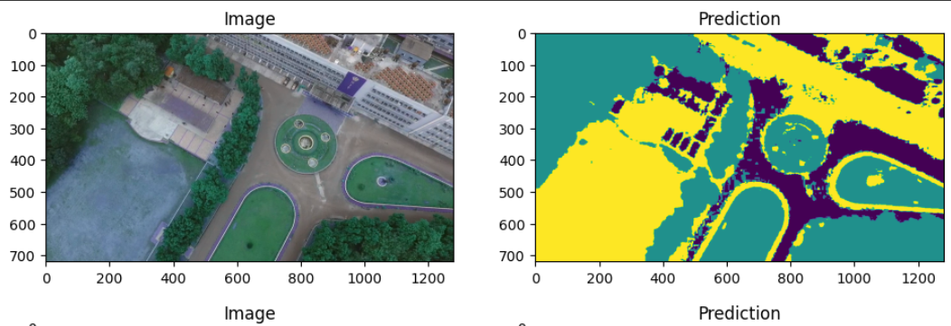

Figure 5.2: Segmented output image of a sample test image

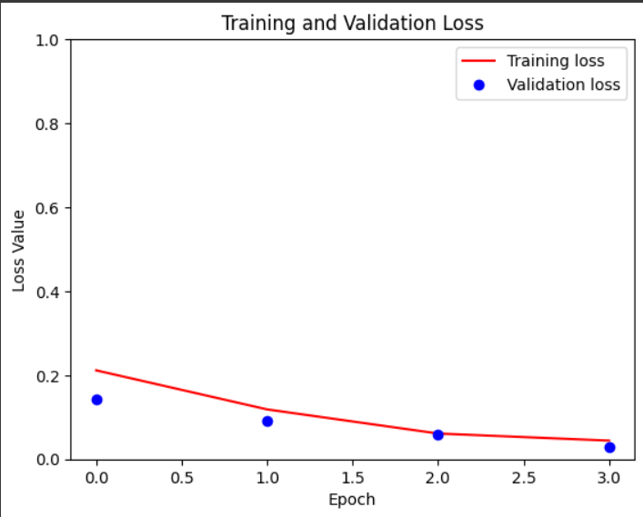

Figure 5.3: Graph of training and validation loss between epoch and loss value.

**Chapter 6**

**6.1 Conclusion**

In conclusion, image segmentation is a critical task in computer vision that involves dividing an image into multiple segments or regions to extract meaningful information from it. With the advancements in deep learning techniques, such as convolutional neural networks and semantic segmentation, significant progress has been made in the field of image segmentation, making it more accurate and efficient. The use of these techniques has resulted in various applications, such as object recognition, medical imaging, autonomous driving, and more. However, there are still some challenges and limitations in image segmentation, such as the difficulty of segmenting complex scenes, the lack of annotated data for certain domains, and the trade-off between accuracy and speed. Hence, there is a need for further research in developing more robust and efficient image segmentation techniques.

**6.2 Future Scope**

In the future, the focus will be on developing techniques that can perform segmentation tasks on a larger scale, with faster processing times, and with fewer training data requirements. There will also be an emphasis on integrating segmentation techniques with other computer vision tasks, such as object detection, tracking, and recognition, to develop more advanced and sophisticated systems for real-world applications. Additionally, the use of unsupervised and self-supervised learning techniques will become more prevalent, allowing for the development of segmentation models with fewer data requirements and improved generalization capabilities.

**References**

[1] Yue, K., Yang, L., Li, R., Hu, W., Zhang, F., & Li, W. (2019). TreeUNet: Adaptive tree convolutional neural networks for subdecimeter aerial image segmentation. *ISPRS Journal of Photogrammetry and Remote Sensing*, *156*, 1-13.

[2] Gupta, A., Watson, S., & Yin, H. (2021). Deep learning-based aerial image segmentation with open data for disaster impact assessment. *Neurocomputing*, *439*, 22-33.

[3] An efficient brain tumor image segmentation based on deep residual networks (ResNets)

[4] Li, N., Huo, H., Zhao, Y. M., Chen, X., & Fang, T. (2013). A spatial clustering method with edge weighting for image segmentation. *IEEE Geoscience and Remote Sensing Letters*, *10*(5), 1124-1128.

[5] Wang, Z., & Boesch, R. (2007). Color-and texture-based image segmentation for improved forest delineation. *IEEE Transactions on Geoscience and Remote Sensing*, *45*(10), 3055-3062.

[6] Esch, T., Thiel, M., Bock, M., Roth, A., & Dech, S. (2008). Improvement of image segmentation accuracy based on multiscale optimization procedure. *IEEE Geoscience and Remote Sensing Letters*, *5*(3), 463-467.

[7] Du, G., Cao, X., Liang, J., Chen, X., & Zhan, Y. (2020). Medical image segmentation based on u-net: A review. *Journal of Imaging Science and* Technology.

[8] Kaiser, P., Wegner, J. D., Lucchi, A., Jaggi, M., Hofmann, T., & Schindler, K. (2017). Learning aerial image segmentation from online maps. *IEEE Transactions on Geoscience and Remote Sensing*, *55*(11), 6054-6068.

[9] Broni-Bediako, C., Murata, Y., Mormille, L. H., & Atsumi, M. (2021). Evolutionary NAS for aerial image segmentation with gene expression programming of cellular encoding. *Neural Computing and Applications*, 1-20.

[10] Behera, T. K., Bakshi, S., Nappi, M., & Sa, P. K. (2023). Superpixel-Based Multiscale CNN Approach Toward Multiclass Object Segmentation From UAV-Captured Aerial Images. *IEEE Journal of Selected Topics in Applied Earth Observations and Remote Sensing*, *16*, 1771-1784.